**Basic Analysis of the Iris Dataset – using Data Visualization tools like Power BI/Tableau**

The Iris dataset contains 4 numerical attributes (4 measures) i.e., sepal length, sepal width, petal length and petal width and one predictive attribute i.e., species (Iris Setosa, Iris Versicolor, Iris Virginica). The 4 numerical attributes can be used to predict the species of the flower that has been classified into three species.

We are using tableau as visualization tool to extract the insights regarding the iris dataset.

The visualization can be done on the basis of Correlations, Patterns and Trends, respectively….

**Correlations**: In this phase we use calculated field to visualize correlation between Sepal Length and Sepal Width with respect to species.

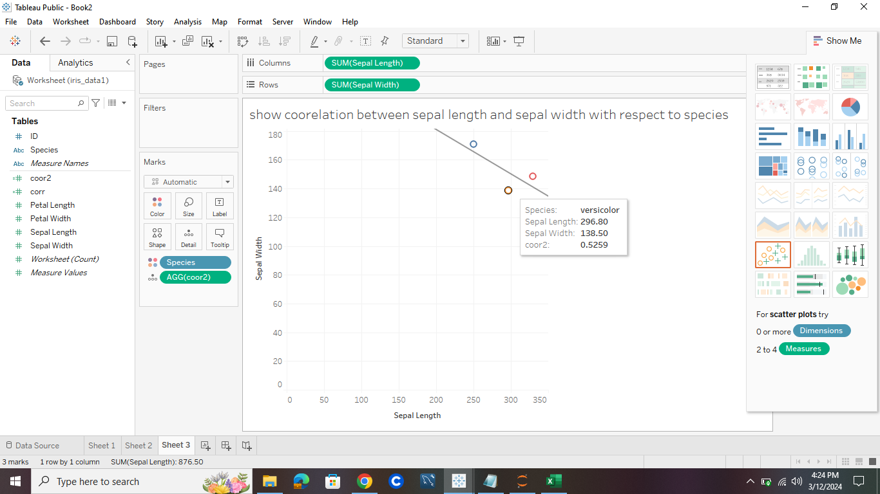

In above picture we are able to see the correlation between the sepal length and sepal width for the species like setosa, versicolor, virginica individually.

Ex:- the above graph is showing versicolor with sepal length: 296.80 ,sepal width: 138.50 and correlation between the sepal length and sepal width for the versicolor is 0.5259.

**Patterns:**  The Patterns in this data can be visualized like scatterplots, line charts, bar charts, and heatmaps.

These visualizations can help to identify outliers, relationships within the data.

The dataset has 4 attributes that is petal length, sepal length, petal width and sepal width and we are extracting the patterns with the help of these attributes.

**Bar chart:**

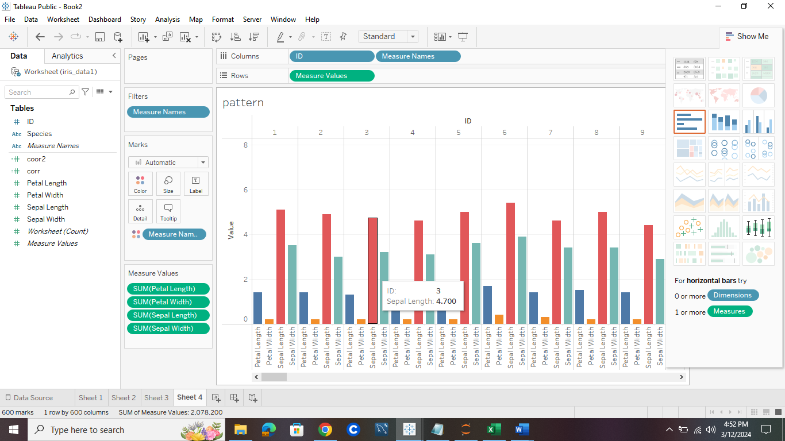

The above paragraph is showing the patterns and relationship between the sepal length, sepal width, petal length, petal width with respect to dimension-species and ID.

**Trends**: Trend lines are used for visualization on data how data is changing over time. These

Can identify upward or downward trends, seasonality in the data.

The 4 numerical attributes can be used to predict the species of the flower that has been classified into three species.

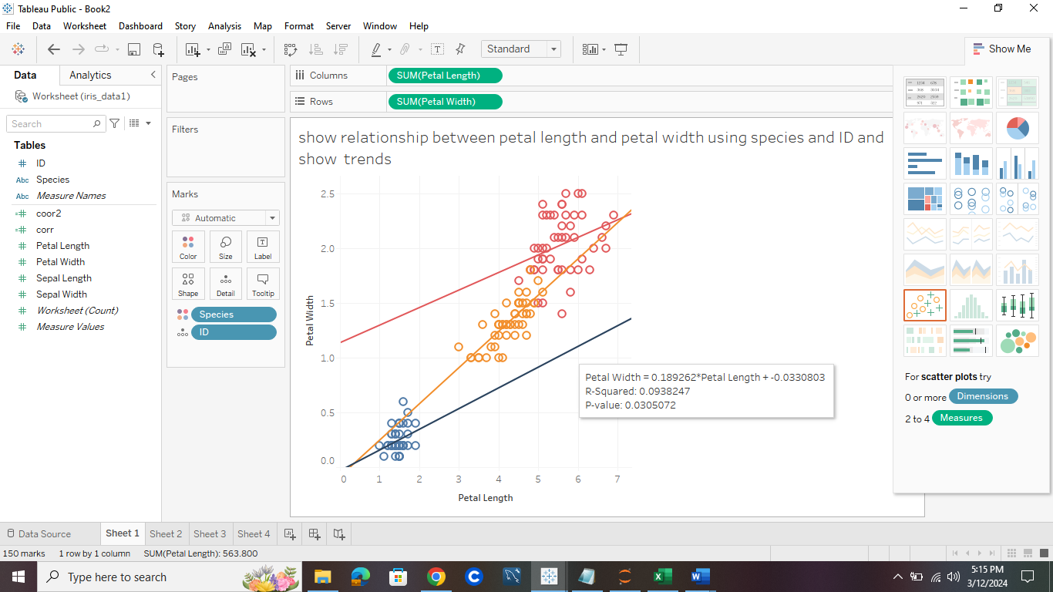

The above graph can be used to infer that the Iris can be classified using the petal length and petal width because the length and width of *Iris setosa* are much smaller than *Iris versicolor* and *Iris virginica*. Then in the range of 1 to 1.7 cm petal width and 3 to 5 cm petal length the Iris versicolor can be classified and the Iris Setosa has the maximum range of petal width and length that is 1.5 to 2.5 cm and 5 to 7 cm.